

VISVESVARAYA TECHNOLOGICAL UNIVERSITY “JNANA SANGAMA”, BELAGAVI - 590 018

MINI PROJECT REPORT
on

“Campus Digital Notice Hub”
Submitted by

Sanjana Naik 4SF25CS419
Prarthana A C 4SF24CS143

In partial fulfillment of the requirements for the IV semester
WEB DEVELOPMENT
(Ability Enhancement Course - BCS408A4)

Under the Guidance of

Ms. Alakananda K Dr. Poornima B V
Assistant Professor Associate Professor

BACHELOR OF ENGINEERING
In
COMPUTER SCIENCE & ENGINEERING

SAHYADRI

College of Engineering & Management An Autonomous Institution
MANGALURU 2025 - 26



Department of Computer Science & Engineering

CERTIFICATE
This is to certify that the mini project work entitled “Campus Digital Notice Hub” has been carried out by Sanjana Naik (4SF25CS419) and Prarthana A C(4SF24CS143), the bonafide students of Sahyadri College of Engineering & Management in partial fulfillment of the requirements for the IV semester Web Development (AEC course), of Bachelor of Engineering in Computer Science and Engineering of Visvesvaraya Technological University, Belagavi during the year 2025 - 26. It is certified that all suggestions indicated for Internal Assessment have been incorporated in the report deposited in the departmental library. The project report has been approved as it satisfies the academic requirements in respect of project work prescribed for the said degree.

Project Guide Ms. Alakananda Assistant Professor
Project Guide Dr. Poornima B V Associate Professor

HoD
Dr. Mustafa Basthikodi
Professor & Head

External Evaluators (Name & Signature) 1.

2.

kkhkhhWe


We hereby declare that the entire work embodied in this Mini Project Report titled “Campus Digital Notice Hub” has been carried out by us at Sahyadri College of Engineering & Management, Mangaluru under the supervision of Ms. Alakananda K and Dr. Poornima B V, in partial fulfillment of the requirements for the IV semester Web Development (AEC course), of Bachelor of Engineering in Computer Science and Engineering. This report has not been submitted to this or any other University for the award of any other degree.

DECLARATION

Sanjana(4SF25CS419) Prarthana A C(4SF24CS143) Dept. of CSE, SCEM, Mangaluru

iii

Abstract
The Campus Digital Notice Hub is a web-based application developed to modernize and streamline the dissemination of official notices and announcements within an educational institution. Traditional notice boards are static, inaccessible to off-campus users, and lack the ability to organize or filter information efficiently. This project addresses these limitations by providing a centralized, role-based digital platform built using the MERN stack (MongoDB, Express.js, React, and Node.js).
The system supports two primary user roles: Faculty and Student. Faculty members can create, manage, and delete notices with defined expiry dates. Once expired, notices are automatically archived and made accessible through an "Old Notices" section. Students can browse active notices, filter them by category, faculty name, or date range, and submit requests to post notices, which are subject to faculty approval.
Key features include role-based access control enforced through JWT authentication, an anti-spam mechanism that limits student notice requests to three per day, and advanced filtering capabilities. The frontend is developed in React with a responsive dark-themed user interface, while the backend uses Node.js and Express.js with MongoDB as the database. The application ensures institutional email domain validation, restricting access to verified campus members only. This system improves campus communication efficiency and promotes transparency in academic administration.

Table of Contents

Content | Page No.
Abstract | i
Table of Contents | ii
1. Introduction 1.1 Overview 1.2 Scope & Motivation | 1
2. Literature Survey | 3
3. Problem Formulation 3.1 Problem Description 3.2 Problem Statement  3.3 Objectives 3.4 Functional Requirements 3.5 Non-Functional Requirements | 7
4. Project Design and Implementation 4.1 High Level Design 4.2 Detailed Design 4.3 Tools and Technologies | 10
5. Results and Discussion 5.1 Experimentation Environment Setup 5.2 Front End GUI Snapshots 5.3 Back End Description 5.4 Societal Impact  5.5 SDG Mapped | 14
Conclusion and Future Scope | 21
References | 22

Chapter 1

Introduction

Overview
In modern educational institutions, effective communication between faculty, staff, and students is paramount. Campus notice boards serve as the primary medium for disseminating important announcements related to academics, events, scholarships, and administrative matters. However, conventional physical notice boards suffer from numerous drawbacks: they are geographically limited, prone to vandalism or damage, cannot be accessed remotely, and lack any form of categorization or search capability.
The Campus Digital Notice Hub is a full-stack web application designed to overcome these limitations. Built on the MERN (MongoDB, Express.js, React, Node.js) technology stack, the system provides a centralized and secure platform where institutional notices can be created, managed, and consumed digitally. The platform implements strict role-based access control, ensuring that only authorized users can perform specific actions.
Faculty members are given the authority to create and manage notices, each of which carries a defined expiry date. Once expired, notices are automatically archived and placed into an "Old Notices" section, keeping the main notice board clean and relevant. Students, on the other hand, can browse active notices, search by keywords, filter by category, faculty name, or date range, and also submit notice-posting requests that are subject to faculty approval. A built-in anti-spam mechanism limits students to three requests per day.
The system uses JWT (JSON Web Token) authentication for secure login and session management, and restricts registration to users with a valid institutional email domain (@sahyadri.edu.in), ensuring that access remains exclusive to campus members. The frontend is built with React using functional components and hooks, offering a clean, responsive, dark-themed user interface for an excellent user experience.

Scope & Motivation
The scope of this project encompasses the complete development of a role-based digital notice board system for Sahyadri College of Engineering and Management. The system is designed to

handle all types of institutional notices including academic calendars, scholarship announcements, examination schedules, event notifications, seating arrangements, and general administrative updates.
The motivation behind this project stems from the need to digitally transform campus communication. The reliance on physical notice boards creates barriers for students who are off-campus, and often results in important notices going unnoticed. By shifting to a digital platform, the institution can ensure timely and organized delivery of information to all stakeholders. The system also empowers students to participate in campus communication by enabling them to submit notice requests, while maintaining administrative control through a moderation workflow.
Furthermore, this project serves as a practical implementation of modern web development concepts including RESTful API design, database schema modeling, middleware-based authentication, real-time state management, and responsive UI development, thereby contributing to the academic enrichment of the developers.

Chapter 2

Literature Survey
The following references provide the foundational knowledge and inspiration for the development of the Campus Digital Notice Hub. These sources encompass prior research on digital notice board systems, role-based access control, MERN stack development, and campus communication technologies.
- A. Kumar and R. Sharma, "Digital Notice Board System for Educational Institutions Using IoT and Cloud," International Journal of Computer Applications, vol. 182, no. 5, pp. 12–18, 2019. This paper presents a cloud-connected digital notice board leveraging IoT for automatic content updates. The key finding is that digitization of notice boards dramatically reduces missed announcements. However, the system lacks role-based access control and student interaction features, a gap addressed in this project.
- M. Patil and S. Joshi, "Web-Based Electronic Notice Board System," International Journal of Engineering Research & Technology (IJERT), vol. 8, no. 6, pp. 230–234, 2019. The authors developed a web-based notice system using PHP and MySQL. The system enables faculty to post notices online. The gap identified is the absence of expiry-based auto-archiving and any kind of student participation mechanism, both of which are core features of the Campus Digital Notice Hub.
- T. Okonkwo and E. Eze, "Role-Based Access Control in Web Applications: A Review," Journal of Information Security, vol. 11, no. 3, pp. 155–170, 2020. This review outlines best practices for implementing RBAC in web systems using token-based authentication. The paper directly informs the authentication and authorization design of this project. The key gap noted is the lack of practical implementation examples using modern JavaScript frameworks.
- S. Gupta and P. Mehta, "MERN Stack Application Development: A Practical Approach," Proceedings of the International Conference on Computational Intelligence, 2021. This paper provides a comprehensive overview of building scalable web applications using MongoDB, Express, React, and Node.js. It guided the technology selection for this project. The gap is that the paper does not address domain-restricted authentication.

- R. Verma, "Spam Prevention in Web Applications Using Rate Limiting Techniques," International Journal of Network Security, vol. 22, no. 4, pp. 678–685, 2020. This research evaluates various rate limiting strategies for preventing form submission abuse. The rate-limiting mechanism used in this project (max 3 requests/day per user) is informed by the findings of this paper.
- J. Patel and A. Desai, "JWT Authentication in RESTful APIs: Security Analysis and Best Practices," International Journal of Web Engineering, vol. 9, no. 2, pp. 45–56, 2021. This paper evaluates the security of JWT-based authentication for REST APIs. The middleware-based route protection strategy adopted in this project is aligned with the recommendations of this study.
- N. Singh and A. Kaur, "Real-Time Notification Systems in Educational Web Portals," Computers & Education, vol. 160, pp. 1–10, 2021. The study examines notification systems in e-learning platforms and the impact of timely alerts on student engagement. The expiry-based notification logic in this project is inspired by the time-sensitive alert mechanisms described here.
- B. Mohan and C. Rajan, "MongoDB Schema Design for Content Management Systems," International Journal of Database Management, vol. 15, no. 3, pp. 22–30, 2020. This paper discusses NoSQL schema design strategies for content-heavy systems. The database schema for the Notices and NoticeRequests collections in this project follows the embedded document pattern recommended by the authors.
- S. Agarwal, "Responsive Web Design Using React.js: Principles and Practices," Advances in Computer Science, vol. 7, no. 1, pp. 100–112, 2022. This paper reviews the use of React functional components and hooks for building responsive UIs. The component design and state management approach in the frontend of this project aligns with the patterns outlined here.
- L. Chen and H. Wang, "Expiry-Based Content Lifecycle Management in Web Applications," Journal of Software Engineering, vol. 16, no. 4, pp. 300–312, 2021. The authors propose a lifecycle model for content that transitions through active, archived, and deleted states based on time conditions. The auto-archiving logic used in this project for moving expired notices to "Old Notices" is directly based on this model.
- F. Obi and K. Nwosu, "Student-Driven Content Moderation in Campus Portals: A Framework," African Journal of Computing & ICT, vol. 14, no. 2, pp. 67–75, 2022. This paper

proposes a moderation framework for student-generated content in campus web systems. The approval workflow for student notice requests in this project is modeled on this framework, addressing the gap of uncontrolled content submissions.

Chapter 3

Problem Formulation

Problem Description
Educational institutions rely heavily on notice boards for communicating critical information to students, faculty, and administrative staff. Physical notice boards, while traditional, are inherently limited in their reach and usability. They can only be accessed in person, and with the increasing prevalence of off-campus learning and remote access needs, students and staff who are not physically present on campus are entirely cut off from essential notices.
Moreover, physical boards are subject to unauthorized removal of notices, weather damage, cluttered displays, and a complete lack of categorization. There is no way to search for specific notices, filter by type, or access past notices that have been removed. Faculty members have no centralized system to track the notices they have posted, and students have no official channel to request the posting of notices.
The absence of a digital infrastructure for notice management also means there is no audit trail, no automated archiving of expired content, and no mechanism to ensure that only authorized personnel can post notices. These issues collectively hamper efficient communication within the campus ecosystem.

Problem Statement
To design and develop a secure, web-based Campus Digital Notice Hub that enables role-based management and consumption of institutional notices, with automated expiry handling, advanced filtering, and a student request moderation workflow, accessible exclusively to verified institutional email users.

Objectives
    - To develop a secure authentication system using JWT that restricts access to users with valid institutional email domains.
    - To implement role-based access control differentiating Faculty and Student roles with distinct permissions.
    - To enable faculty members to create, update, archive, and delete notices with expiry dates.

    - To automatically archive expired notices and make them accessible in an "Old Notices" section.
    - To provide students with a notice request submission system subject to faculty approval with rate limiting.
    - To implement advanced search and filtering by category, faculty name, keywords, and date range.
    - To build a responsive, intuitive user interface with role-specific dashboards.
    - To ensure data security through input validation, password hashing, and protected API routes.

Functional Requirements

Authentication & Authorization:
    - User registration with institutional email domain validation (@sahyadri.edu.in).
    - Secure login using JWT tokens with role-based session management.
    - Role assignment at registration: Student or Faculty.

Notice Management (Faculty):
    - Create notices with title, description, category, and expiry date.
    - Edit and delete existing notices.
    - View all notices including archived ones.
    - Review, approve, or reject student notice requests with optional review notes.

Notice Viewing (Student):
    - Browse all active notices on the Notice Board.
    - Access archived notices in the Old Notices section.
    - Filter notices by category, faculty name, keyword, and date range.
    - Submit notice posting requests with a daily limit of 3 requests.

System Features:
    - Automatic expiry-based archiving of notices.

    - Dashboard with statistics: active notices, archived notices, pending requests.
    - Toast notifications for user actions.

Non-Functional Requirements
    - Security: All routes protected by JWT middleware; passwords hashed using bcrypt.
    - Performance: Efficient MongoDB queries with pagination for notice listings.
    - Usability: Responsive UI accessible on desktop and mobile browsers.
    - Scalability: Modular code structure allowing easy addition of new features.
    - Reliability: Proper error handling on both frontend and backend.
    - Maintainability: Clean, modular code with separation of concerns (MVC pattern).

Chapter 4

Project Design and Implementation

High Level Design
The Campus Digital Notice Hub follows a three-tier architecture: a React-based frontend (client tier), a Node.js/Express.js backend (application tier), and a MongoDB database (data tier). Communication between the frontend and backend occurs via RESTful HTTP APIs, with JWT tokens carried in request headers for authentication.
The high-level data flow is as follows: A user logs in through the React frontend, which sends credentials to the Express.js authentication API. Upon successful validation, a JWT is returned and stored on the client. Subsequent API calls include this JWT in the Authorization header. The backend middleware verifies the JWT and checks the user role before processing any request.
Notices posted by faculty are stored in MongoDB with an expiry date field. A scheduled check (or query-time filter) identifies notices whose expiry date has passed and classifies them as archived. Students browse active notices and can submit notice requests, which are stored in a separate NoticeRequests collection and await faculty approval.

Detailed Design
Database Schema:
Users Collection: Stores user information including full name, email, hashed password, role (Student/Faculty), and creation timestamp. The email field enforces uniqueness and domain validation.
Notices Collection: Stores notice title, description, category (Scholarship, Event, Academic, Exam, Seating Arrangement, General), createdBy (reference to User), postedDate, expiryDate, and status (active/archived).
NoticeRequests Collection: Stores student notice requests including title, description, category, requestedBy (reference to User), requestedExpiry, status (pending/approved/rejected), reviewNote, and createdAt timestamp.
API Endpoints:

    - POST /api/auth/register - User registration with email domain validation
    - POST /api/auth/login - JWT-based authentication
    - GET /api/notices - Retrieve active notices with optional filters
    - GET /api/notices/archived - Retrieve archived/expired notices
    - POST /api/notices - Create a new notice (Faculty only)
    - PUT /api/notices/:id - Update a notice (Faculty only)
    - DELETE /api/notices/:id - Delete a notice (Faculty only)
    - POST /api/requests - Submit a notice request (Student only)
    - GET /api/requests - Get all requests (Faculty) or user requests (Student)
    - PUT /api/requests/:id/approve - Approve a request (Faculty)
    - PUT /api/requests/:id/reject - Reject a request (Faculty) Frontend Component Structure:
    - Login.jsx / Register.jsx - Authentication pages with form validation
    - Dashboard.jsx - Role-based dashboard with statistics cards
    - NoticeBoard.jsx - Active notices display with search and filter controls
    - OldNotices.jsx - Archived notices section
    - SubmitRequest.jsx - Student notice request form with request history
    - ManageNotices.jsx - Faculty notice management with CRUD operations
    - Requests.jsx - Faculty review panel for student requests

Tools and Technologies Used for Implementation

Frontend:
    - React.js - JavaScript library for building user interfaces using functional components and hooks
    - React Router DOM - Client-side routing for single-page application navigation
    - Axios - HTTP client for API communication
    - React Hot Toast - Toast notification library for user feedback

    - Tailwind CSS - Utility-first CSS framework for responsive dark-themed design

Backend:
    - Node.js - JavaScript runtime environment for server-side execution
    - Express.js - Minimal and flexible Node.js web application framework
    - Mongoose - MongoDB object modeling tool for schema definition and validation
    - JSON Web Token (JWT) - Secure token-based authentication
    - bcryptjs - Password hashing library for secure credential storage
    - dotenv - Environment variable management

Database:
    - MongoDB Atlas - Cloud-hosted NoSQL database for storing users, notices, and requests

Development Tools:
    - VS Code - Primary code editor
    - Postman - API testing and documentation
    - Git & GitHub - Version control and code repository
    - npm - Package manager for Node.js dependencies

Chapter 5

Results and Discussion

Experimentation Environment Setup
The Campus Digital Notice Hub was developed and tested on a local development environment Setup Instructions to follow inorder to run in the PC:
    - Clone the project repository from GitHub.
    - Navigate to /server and run npm install to install backend dependencies.
    - Create a .env file in /server with MONGO_URI, JWT_SECRET, and PORT variables.
    - Run npm start or node server.js to start the backend server.
    - Navigate to /client and run npm install to install frontend dependencies.
    - Run npm start to launch the React frontend on localhost:3000.

Front End GUI Screenshots
The following screenshots demonstrate the key user interfaces of the Campus Digital Notice Hub application:
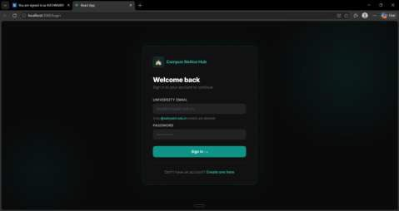
Fig. 1: Login Page
The Login Page (Fig. 1) presents a clean, dark-themed interface where users authenticate using their institutional email (restricted to @sahyadri.edu.in domain) and password. The form validates

inputs and displays appropriate error messages for invalid credentials or unauthorized email domains.
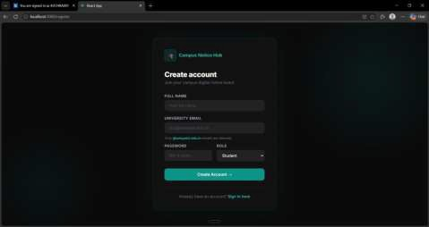
Fig. 2: Registration Page
The Registration Page (Fig. 2) allows new users to create an account by providing their full name, institutional email, password, and selecting a role (Student or Faculty). The system enforces @sahyadri.edu.in email validation and minimum password length of 6 characters.
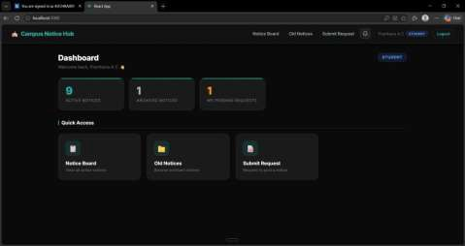
Fig. 3: Student Dashboard
The Student Dashboard (Fig. 3) displays a personalized welcome message and real-time statistics including active notices count, archived notices count, and the number of pending requests submitted by the student. Quick access cards provide navigation to key sections of the application.

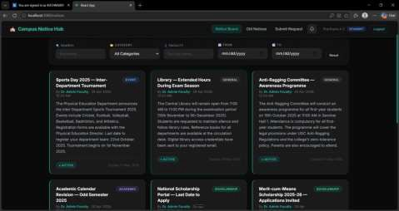
Fig. 4: Notice Board
The Notice Board (Fig. 4) displays all active notices in a responsive card grid layout. Each card shows the notice title, category badge, author, posting date, description, status, and expiry date. The search bar and filters for category, faculty name, and date range allow users to quickly find relevant notices.
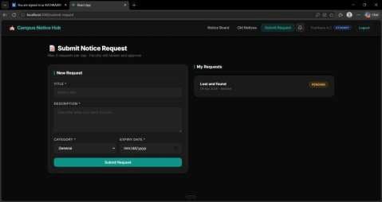
Fig. 5: Submit Notice Request (Student)
The Submit Notice Request page (Fig. 5) allows students to fill in a request form with title, description, category, and expiry date. The right panel displays the student's previously submitted requests along with their current status (Pending, Approved, or Rejected). The system enforces a maximum of 3 requests per day.

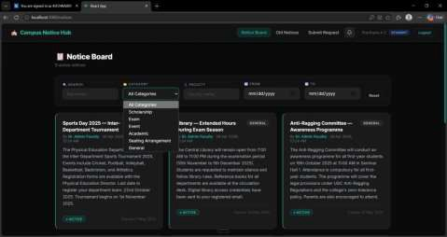
Fig. 6: Category Filter Dropdown
Fig. 6 shows the category filter dropdown on the Notice Board page. Users can filter notices by categories including Scholarship, Exam, Event, Academic, Seating Arrangement, and General. This filtering system helps students quickly locate notices relevant to their interests.
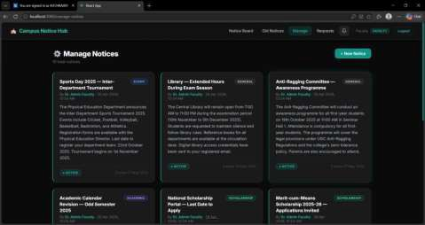
Fig. 7: Manage Notices (Faculty View)
The Manage Notices page (Fig. 7) is accessible only to Faculty role users. It displays all notices (both active and archived) and provides a "+ New Notice" button for creating new announcements. Faculty can also edit or delete existing notices from this view, giving complete control over campus notices.

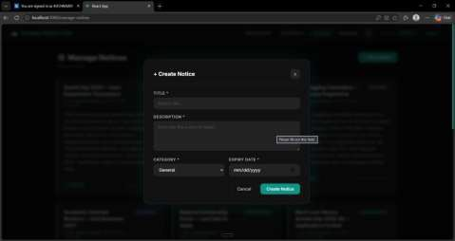
Fig. 8: Create Notice Modal (Faculty)
Fig. 8 shows the Create Notice modal that appears when a faculty member clicks "+ New Notice." The form requires a title, description, category selection, and expiry date. HTML5 form validation ensures all required fields are filled before submission.
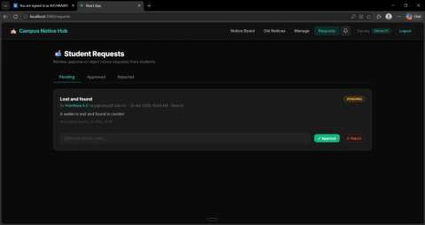
Fig. 9: Student Requests Review (Faculty)
The Student Requests page (Fig. 9) is visible only to Faculty users. It displays pending, approved, and rejected student notice requests with tabs for each status. Faculty can review the request details, add an optional review note, and click Approve or Reject to process each request.

Back End Description

The backend of the Campus Digital Notice Hub is built with Node.js and Express.js. The application is organized into separate folders for routes, controllers, models, middleware, and configuration.
The authentication controller handles user registration with email domain validation and password hashing using bcrypt, and login with JWT token generation. The notice controller manages CRUD operations for notices, with query-time expiry filtering that classifies notices as active or archived based on whether their expiryDate has passed. The request controller manages the student request lifecycle from submission through moderation.
Middleware includes JWT verification (applied to all protected routes) and role-based authorization checks (applied to faculty-only routes). The Mongoose models define schemas with built-in validation for all collections. Error handling middleware ensures consistent error response formatting across all API endpoints.

Societal Impact of the Project
The Campus Digital Notice Hub has significant positive societal impact within the educational community. By digitizing campus communication, the system eliminates the dependency on physical infrastructure, making notices accessible 24/7 from any location with internet connectivity. This is particularly beneficial for students who commute long distances or who have disabilities that limit their physical mobility on campus.
The system promotes transparency in campus administration by creating a digital record of all notices and student requests. The student request moderation workflow empowers students to actively participate in campus communication while maintaining institutional control. The expiry-based archiving ensures that students always see current and relevant information without the clutter of outdated notices.
From an environmental perspective, the system reduces the need for printed notices, contributing to sustainable campus practices and reducing paper waste. It also promotes digital literacy among students and faculty, equipping them with experience using modern web-based systems.

Conclusion and Future Scope
The Campus Digital Notice Hub successfully achieves its objective of modernizing campus communication through a secure, role-based, web-based notice management system. The application demonstrates the practical integration of modern full-stack web development technologies, including React.js for the frontend, Node.js and Express.js for the backend, and MongoDB for data storage, within a structured MERN stack architecture.
The system effectively addresses the key limitations of traditional physical notice boards by providing 24/7 digital access, automated expiry-based archiving, advanced filtering and search capabilities, and a structured student request moderation workflow. The JWT-based authentication with institutional email domain validation ensures that the platform remains secure and accessible only to verified campus members.
The role-based access control system successfully differentiates between Student and Faculty users, granting appropriate permissions while preventing unauthorized actions. Faculty members benefit from complete notice lifecycle management, while students gain a transparent and interactive channel for accessing and contributing to campus communication.
The anti-spam rate limiting mechanism and the approval workflow for student requests maintain content quality and prevent misuse of the platform. The responsive dark-themed UI provides an excellent user experience across devices.
Future Scope:
- Push Notifications: Implementing real-time push notifications using WebSockets (Socket.io) or Firebase Cloud Messaging to alert users instantly when new notices are posted or requests are processed.
- Mobile Application: Developing native Android and iOS applications using React Native to extend platform accessibility beyond web browsers.
- Admin Role: Adding a super-admin role with capabilities to manage all users, generate analytics reports, and oversee all notices and requests across the institution.
- Email Alerts: Integrating NodeMailer to send automated email notifications to students when notices in their subscribed categories are posted.

- File Attachments: Enabling faculty to attach PDF files, images, or other documents to notices for comprehensive information sharing.
- Analytics Dashboard: Building an analytics module to track notice engagement metrics such as views, category popularity, and request approval rates.
- Department-Based Filtering: Extending the role system to include department-specific notice posting and viewing permissions.
- Multi-Language Support: Adding internationalization (i18n) support to make the platform accessible to users in regional languages.

References
- A. Kumar and R. Sharma, "Digital Notice Board System for Educational Institutions Using IoT and Cloud," International Journal of Computer Applications, vol. 182, no. 5, pp. 12–18, 2019.
- M. Patil and S. Joshi, "Web-Based Electronic Notice Board System," International Journal of Engineering Research & Technology (IJERT), vol. 8, no. 6, pp. 230–234, 2019.
- T. Okonkwo and E. Eze, "Role-Based Access Control in Web Applications: A Review," Journal of Information Security, vol. 11, no. 3, pp. 155–170, 2020.
- S. Gupta and P. Mehta, "MERN Stack Application Development: A Practical Approach," Proceedings of the International Conference on Computational Intelligence, 2021.
- R. Verma, "Spam Prevention in Web Applications Using Rate Limiting Techniques," International Journal of Network Security, vol. 22, no. 4, pp. 678–685, 2020.
- J. Patel and A. Desai, "JWT Authentication in RESTful APIs: Security Analysis and Best Practices," International Journal of Web Engineering, vol. 9, no. 2, pp. 45–56, 2021.
- N. Singh and A. Kaur, "Real-Time Notification Systems in Educational Web Portals," Computers & Education, vol. 160, pp. 1–10, 2021.
- B. Mohan and C. Rajan, "MongoDB Schema Design for Content Management Systems," International Journal of Database Management, vol. 15, no. 3, pp. 22–30, 2020.
- S. Agarwal, "Responsive Web Design Using React.js: Principles and Practices," Advances in Computer Science, vol. 7, no. 1, pp. 100–112, 2022.
- L. Chen and H. Wang, "Expiry-Based Content Lifecycle Management in Web Applications," Journal of Software Engineering, vol. 16, no. 4, pp. 300–312, 2021.
- F. Obi and K. Nwosu, "Student-Driven Content Moderation in Campus Portals: A Framework," African Journal of Computing & ICT, vol. 14, no. 2, pp. 67–75, 2022.

